Analytical Report
The primary objective of this housing.csv dataset is to predict the housing price based on certain factors like house area, bedrooms, furnished, nearness to main road, etc. Variable description is provided below:
area = area of a house
bedrooms = number of house bedrooms
bathrooms = number of house bathrooms
stories = number of house stories
mainroad = whether connected to the main road
guestroom = whether has a guestroom
basement = whether has a basement
hotwaterheating = whether has hot water heater
airconditioning = whether has an airconditioning
parking = the number of parking
price = price of the house

Step 1: Importing data and converting sting variables into dummy variables.
This is the original data:
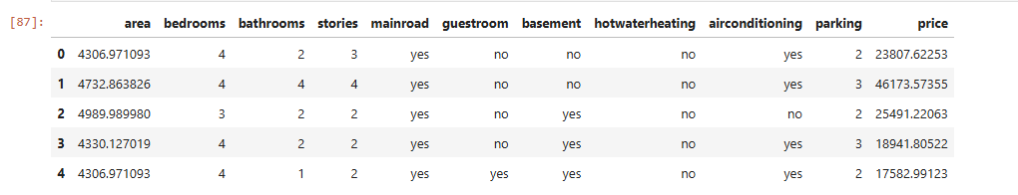
After converting into dummy variables:
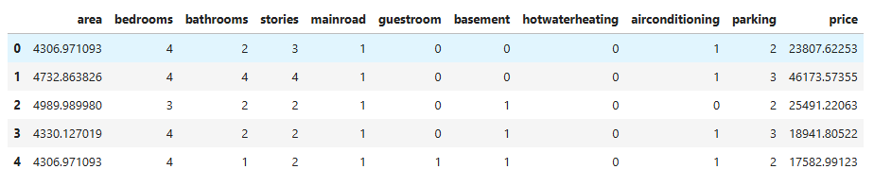
Step 2: We construct scatter plots between dependent variable with each of independent variable
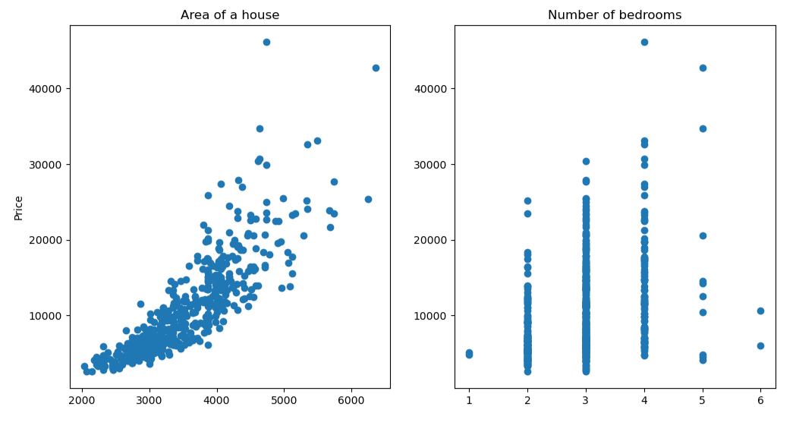
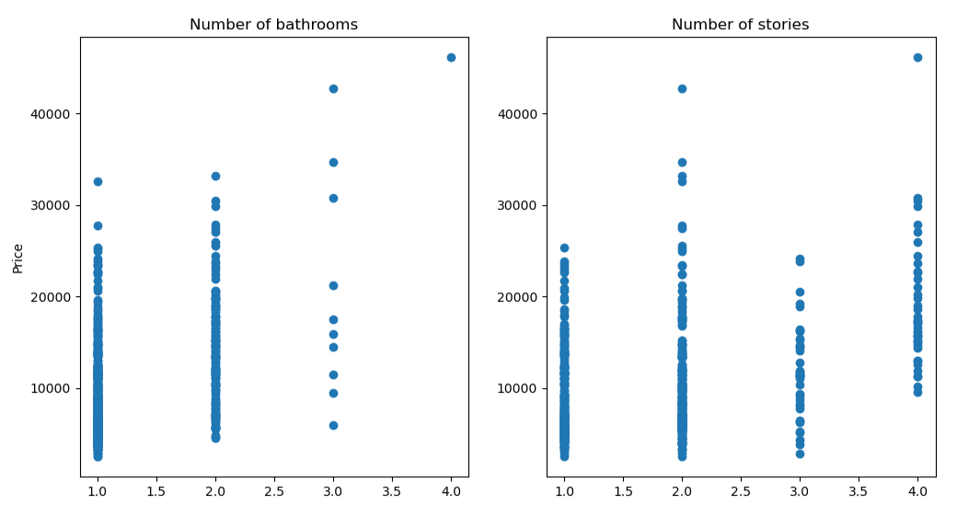
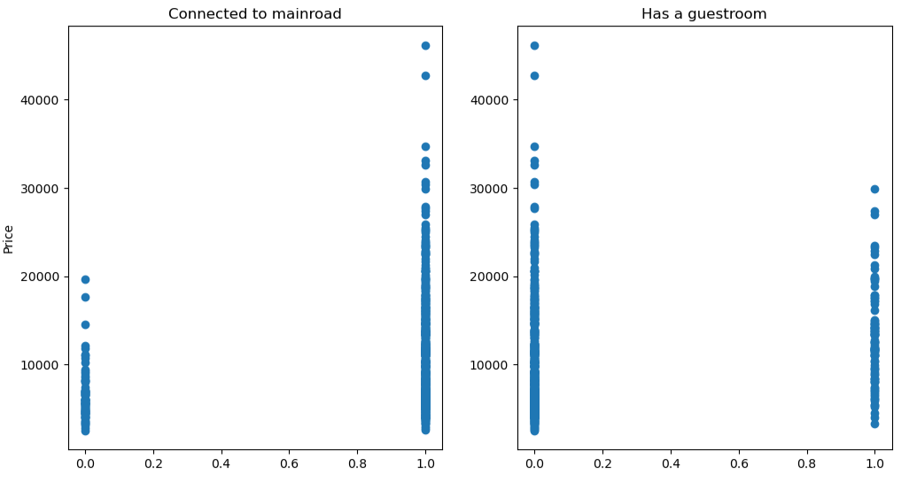
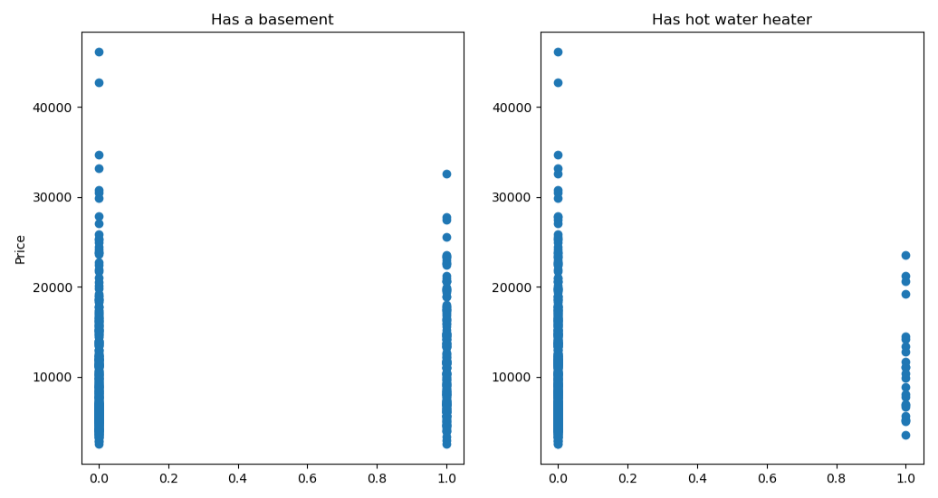
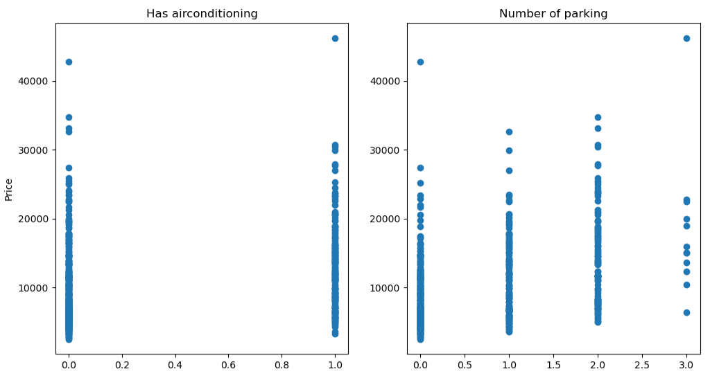
The scatter plots for all independent variables, except the area of the house, suggest that they are discrete variables and show a generally positive relationship with housing price. However, there is some variation in housing prices within each category of these variables. The area of the house shows a slightly positive curved line, which is acceptable and may be considered to be a linear regression relationship with housing price.
Step 3: Fit the values into regression line and construct OLS Regression Result tables.
Construct diagnostic checks for the dataset
OLS Regression Results
==============================================================================
Dep. Variable: price R-squared: 0.868
Model: OLS Adj. R-squared: 0.865
Method: Least Squares F-statistic: 346.4
Date: Thu, 05 Mar 2026 Prob (F-statistic): 7.67e-225
Time: 20:35:14 Log-Likelihood: -4935.6
No. Observations: 540 AIC: 9893.
Df Residuals: 529 BIC: 9940.
Df Model: 10
Covariance Type: nonrobust
===================================================================================
coef std err t P>|t| [0.025 0.975]
-----------------------------------------------------------------------------------
const -1.99e+04 631.814 -31.500 0.000 -2.11e+04 -1.87e+04
area 6.5789 0.158 41.578 0.000 6.268 6.890
bedrooms 308.4766 154.663 1.995 0.047 4.647 612.306
bathrooms 2400.1873 221.901 10.816 0.000 1964.273 2836.102
stories 1702.2485 137.413 12.388 0.000 1432.306 1972.191
mainroad -551.6684 301.545 -1.829 0.068 -1144.041 40.704
guestroom -188.2469 284.738 -0.661 0.509 -747.603 371.109
basement 1331.7594 232.131 5.737 0.000 875.747 1787.772
hotwaterheating -358.8964 483.557 -0.742 0.458 -1308.824 591.031
airconditioning -627.6635 232.231 -2.703 0.007 -1083.871 -171.456
parking 775.0578 125.123 6.194 0.000 529.258 1020.857
==============================================================================
Omnibus: 197.678 Durbin-Watson: 1.748
Prob(Omnibus): 0.000 Jarque-Bera (JB): 1321.689
Skew: 1.444 Prob(JB): 9.97e-288
Kurtosis: 10.099 Cond. No. 2.35e+04
==============================================================================

Notes:
[1] Standard Errors assume that the covariance matrix of the errors is correctly specified.
[2] The condition number is large, 2.35e+04. This might indicate that there are
strong multicollinearity or other numerical problems.

According to the result table, mainroad variable is marginally significant from the 0.05 significant value. Guestroom and hotwaterheating are not significant variables that can affect to our dependent variable.
Other than those mentioned, the remaining independent variables significantly affect the price.
The regression line:
price = -1.99e+04 + 6.5789area + 308.4766bedrooms + 2400.1873bathrooms +1702.2485stories – 551.6684mainroad – 188.2469guestroom + 1331.7594basement – 358.8964hotwaterheating – 627.6635airconditioning

R-squared: 0.868, indicating a good explanation of the variables by regression line
AIC: 9893
BIC: 9940
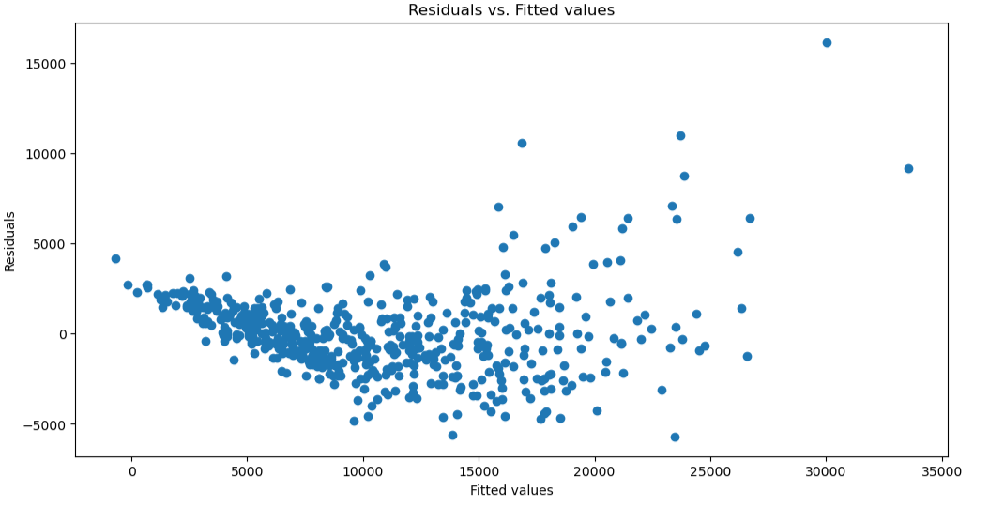
The residual plot shows clear violations in zero mean and constant variance consumptions. Moreover, it suggests there are potential outliers on the right tail of the plot.
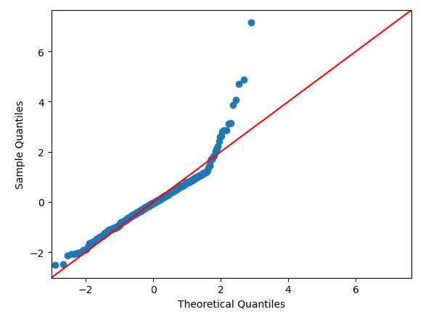
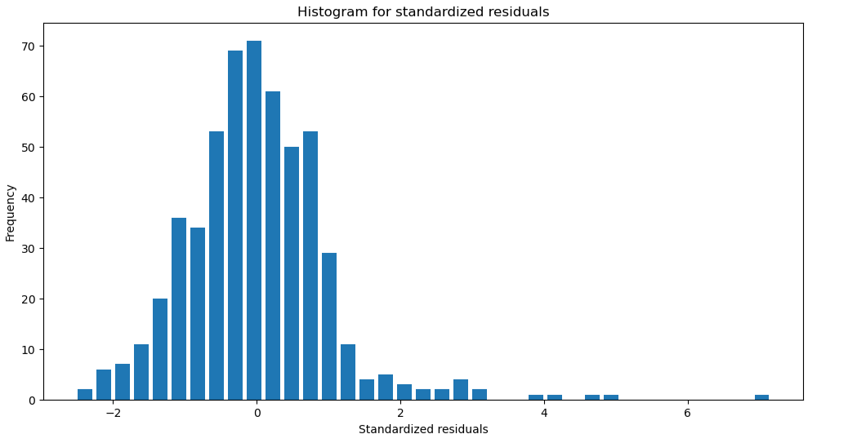
The QQ plot shows that the residuals deviate from the red reference line, particularly in the right tail, suggesting a normality violation and indicating right skewness. The pattern is also represented in histogram plot, where we can see the right skewness caused by potential outliers, which observations lie more than 3 standard deviations away from the mean.
The residual plots from initial regression indicate heteroskedasticity and right-skewed residuals. To stabilize variance and improve the normality of residuals, a log transformation of the dependent variable (price) was applied.
Step 4: Apply log transformation for dependent variable. Construct fitted regression and diagnostic checks for the new dataset
This is the data after log transformation for dependent variable:
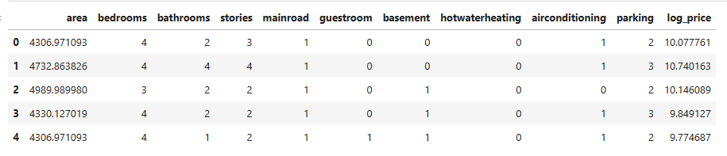

OLS Regression Results
==============================================================================
Dep. Variable: log_price R-squared: 0.910
Model: OLS Adj. R-squared: 0.909
Method: Least Squares F-statistic: 537.2
Date: Thu, 05 Mar 2026 Prob (F-statistic): 1.26e-269
Time: 20:35:29 Log-Likelihood: 218.62
No. Observations: 540 AIC: -415.2
Df Residuals: 529 BIC: -368.0
Df Model: 10
Covariance Type: nonrobust
===================================================================================
coef std err t P>|t| [0.025 0.975]
-----------------------------------------------------------------------------------
const 6.3858 0.045 141.216 0.000 6.297 6.475
area 0.0006 1.13e-05 51.754 0.000 0.001 0.001
bedrooms 0.0373 0.011 3.372 0.001 0.016 0.059
bathrooms 0.1541 0.016 9.704 0.000 0.123 0.185
stories 0.1405 0.010 14.283 0.000 0.121 0.160
mainroad 0.0160 0.022 0.741 0.459 -0.026 0.058
guestroom 0.0250 0.020 1.229 0.220 -0.015 0.065
basement 0.1497 0.017 9.013 0.000 0.117 0.182
hotwaterheating 0.0243 0.035 0.702 0.483 -0.044 0.092
airconditioning -0.0123 0.017 -0.738 0.461 -0.045 0.020
parking 0.0600 0.009 6.695 0.000 0.042 0.078
==============================================================================
Omnibus: 4.442 Durbin-Watson: 1.955
Prob(Omnibus): 0.108 Jarque-Bera (JB): 4.840
Skew: -0.118 Prob(JB): 0.0889
Kurtosis: 3.400 Cond. No. 2.35e+04
==============================================================================

Notes:
[1] Standard Errors assume that the covariance matrix of the errors is correctly specified.
[2] The condition number is large, 2.35e+04. This might indicate that there are
strong multicollinearity or other numerical problems.

After the log transformation of the dependent variable, the result shows that mainroad, guestroom, hotwaterheating and airconditioning are not significant variables. However, the R-squared is improved slightly significant from 0.868 to 0.910.
The regression equation:
log_price = 6.3858 + 0.0006area + 0.0373 bedrooms + 0.1541bathrooms + 0.1405stories + 0.0160mainroad + 0.025guestroom + 0.1497basement + 0.0243hotwaterheating – 0.0123airconditioning + 0.06parking

R-squared: 0.910
AIC = -415.2
BIC = -368
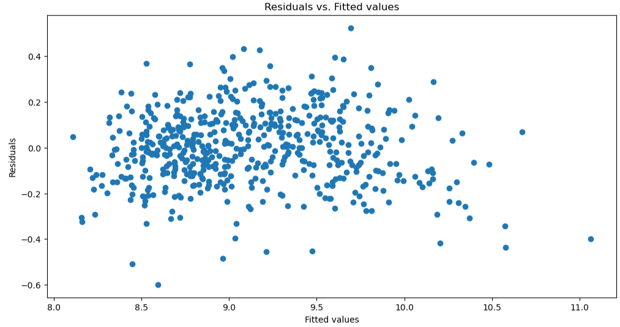
The residuals plot suggests that the log transformation has improved the stability of the variance, as the residuals deviate randomly and have constant distance from 0. indicating there are no violation of zero mean or constant variance assumptions of the regressions model.
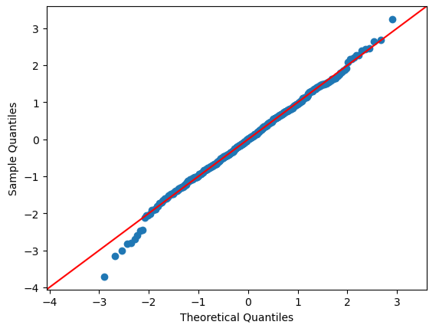
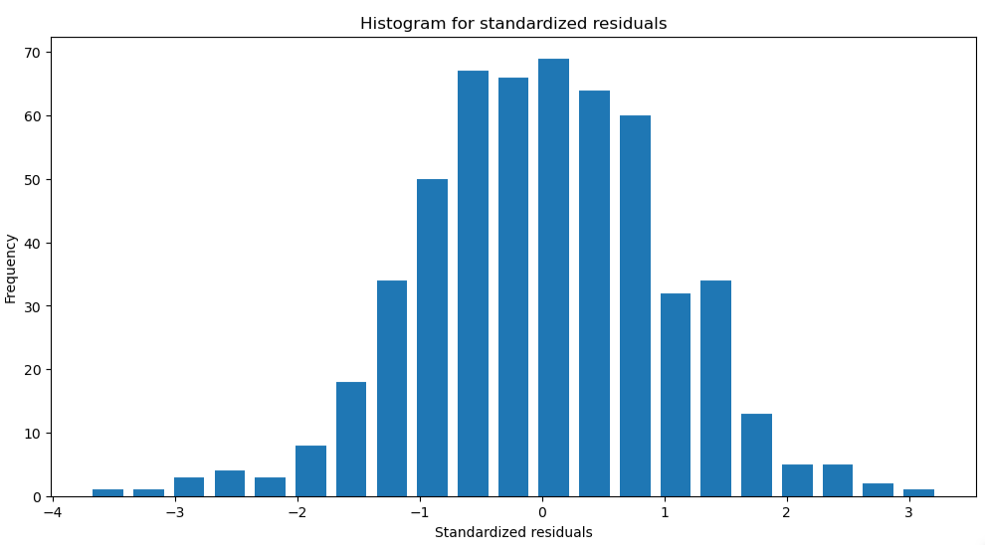
The QQ plot and histogram plot both show slight violation of normality after log transformation and some potential residuals deviate on the left around 4 standard deviation away from the mean, indicating there is still marginally left skewness.
From the OLS result, the large condition number suggests potential multicollinearity among explanatory variables. To construct a more accruate model and retain only significant predictors, forward feature selection is applied.
Step 5: Construct forward feature selection and display the result
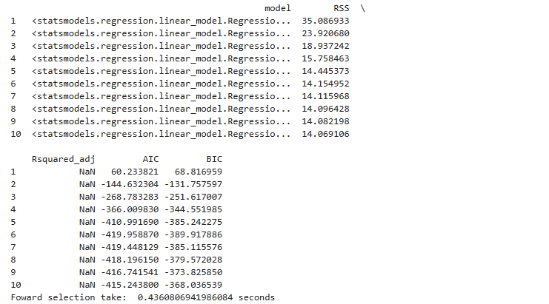
OLS Regression Results
==============================================================================
Dep. Variable: log_price R-squared: 0.910
Model: OLS Adj. R-squared: 0.909
Method: Least Squares F-statistic: 896.2
Date: Fri, 06 Mar 2026 Prob (F-statistic): 1.04e-274
Time: 22:13:23 Log-Likelihood: 216.98
No. Observations: 540 AIC: -420.0
Df Residuals: 533 BIC: -389.9
Df Model: 6
Covariance Type: nonrobust
==============================================================================
coef std err t P>|t| [0.025 0.975]
------------------------------------------------------------------------------
const 6.3922 0.043 147.494 0.000 6.307 6.477
bedrooms 0.0363 0.011 3.307 0.001 0.015 0.058
area 0.0006 1.07e-05 55.182 0.000 0.001 0.001
stories 0.1407 0.009 15.045 0.000 0.122 0.159
bathrooms 0.1546 0.016 9.785 0.000 0.124 0.186
basement 0.1570 0.015 10.242 0.000 0.127 0.187
parking 0.0600 0.009 6.797 0.000 0.043 0.077
==============================================================================
Omnibus: 4.610 Durbin-Watson: 1.959
Prob(Omnibus): 0.100 Jarque-Bera (JB): 5.052
Skew: -0.121 Prob(JB): 0.0800
Kurtosis: 3.407 Cond. No. 2.23e+04
==============================================================================

Notes:
[1] Standard Errors assume that the covariance matrix of the errors is correctly specified.
[2] The condition number is large, 2.23e+04. This might indicate that there are
strong multicollinearity or other numerical problems.

The significant variables after feature selection are bedrooms, area, stories, bathrooms, basement, and parking with p-value is around 0.000, which is less than 0.05 significance.

The regression equation:
Log_price = 6.3922 + 0.0363bedrooms + 0.0006area + 0.1407stories + 0.1546bathrooms + 0.1570basement + 0.0600parking

R-squared: 0.910
AIC = -420
BIC = -389.9
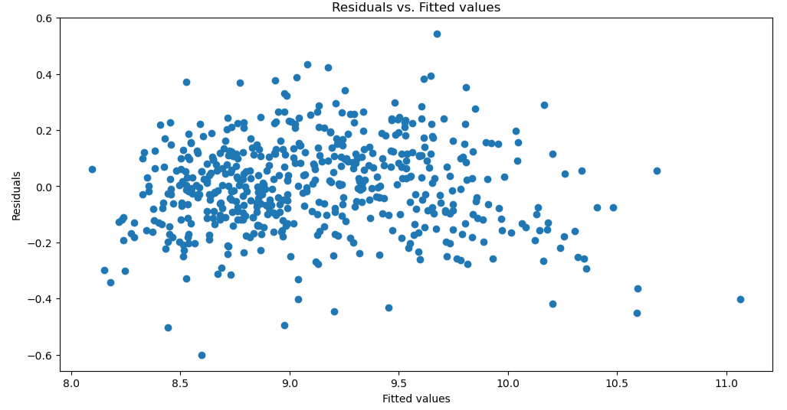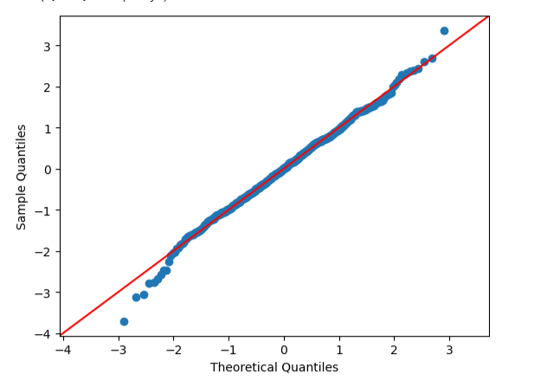
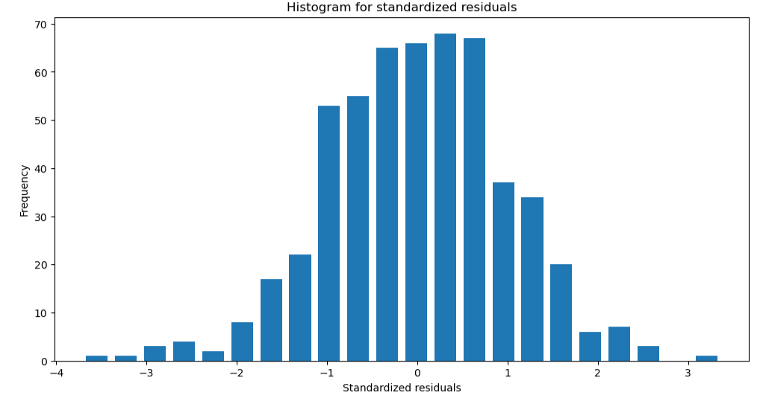
The forward feature selection method has selected significant variables as mentioned above. However, the slight left skewness still appears and the diagnostic plots are mostly the same as those in step 7. This leads to the solution of checking potential outliers and excluding it.
Step 6: Check potential and exclude them. Do the diagnostic checks for the new data.
Using the Interquartile Range (IQR) to identify outliers because the data is skewed due to significant outliers. The following table is the list of outliers that are recorded in the data.
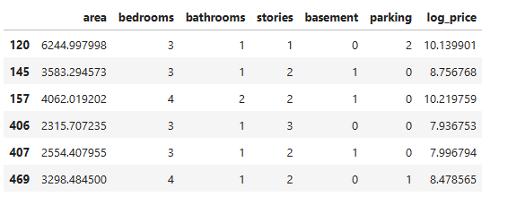
The following table is the data after removing outliers.
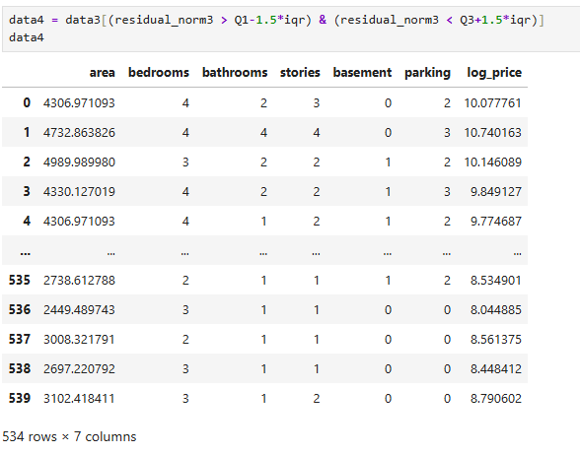
Construct diagnostic checks
OLS Regression Results
==============================================================================
Dep. Variable: log_price R-squared: 0.917
Model: OLS Adj. R-squared: 0.916
Method: Least Squares F-statistic: 970.4
Date: Fri, 06 Mar 2026 Prob (F-statistic): 4.46e-281
Time: 22:13:24 Log-Likelihood: 243.18
No. Observations: 534 AIC: -472.4
Df Residuals: 527 BIC: -442.4
Df Model: 6
Covariance Type: nonrobust
==============================================================================
coef std err t P>|t| [0.025 0.975]
------------------------------------------------------------------------------
const 6.4023 0.041 154.283 0.000 6.321 6.484
area 0.0006 1.03e-05 57.128 0.000 0.001 0.001
bedrooms 0.0377 0.010 3.613 0.000 0.017 0.058
bathrooms 0.1439 0.015 9.574 0.000 0.114 0.173
stories 0.1433 0.009 16.090 0.000 0.126 0.161
basement 0.1573 0.015 10.744 0.000 0.129 0.186
parking 0.0612 0.008 7.285 0.000 0.045 0.078
==============================================================================
Omnibus: 0.799 Durbin-Watson: 1.998
Prob(Omnibus): 0.671 Jarque-Bera (JB): 0.886
Skew: 0.043 Prob(JB): 0.642
Kurtosis: 2.820 Cond. No. 2.24e+04
==============================================================================

Notes:
[1] Standard Errors assume that the covariance matrix of the errors is correctly specified.
[2] The condition number is large, 2.24e+04. This might indicate that there are
strong multicollinearity or other numerical problems.

The result indicates that excluding outliers slightly improves the data statistic information. R-squared increases from 0.910 to 0.917 and AIC, BIC are even smaller than the previous result. Moreover, the regression has the same significant variables as before, which are area, bedrooms, bathrooms, stories, basement, and parking.
The regressions equation:
log_price = 6.4023 + 0.0006area + 0.0377bedrooms + 0.1439bathrooms + 0.1433stories + 0.1573basement + 0.0612parking
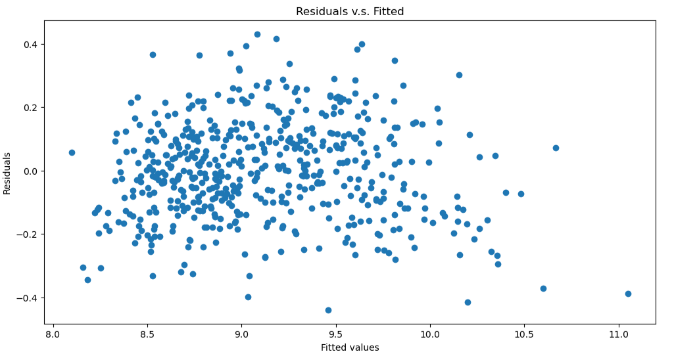
The residual plot shows no violation on either zero mean assumption or constant variance assumption as the step before.

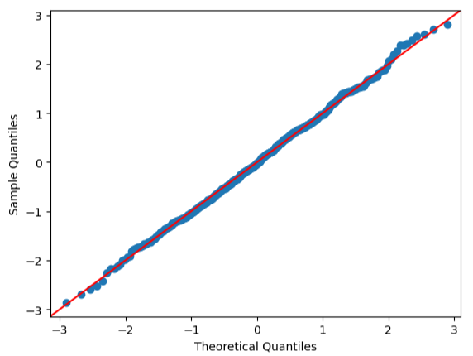
The close alignment of data points to the red reference line validates the normality assumption, suggesting the current model is accurate with no significant skewness.
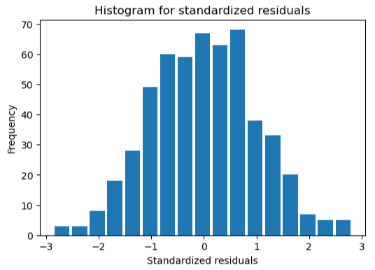
The residuals appear to be a normal distribution in the histogram plot, indicating the validation of the normality assumption and the accuracy of the model to use to predict test data.

Question 1. Do guestroom, basement, hot water heater, and air conditioning significantly influence housing price (significance), and how (magnitude)?
Only the basement significantly influences the housing price. Houses with a basement are expected to have prices approximately 17.03% higher than houses without a basement, holding other variables constant.
The guestroom, hot water heater and air conditioning are not significant factors that influence housing price.
Step 7: Predict the test data using the current model
This is the original test data:
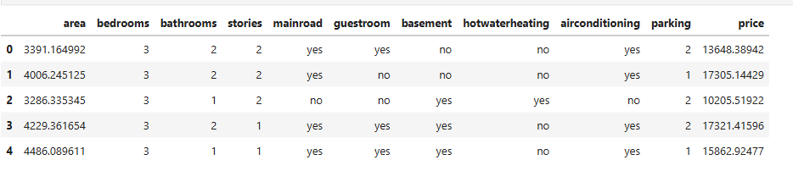
The test data after convert string variables into dummy variables:
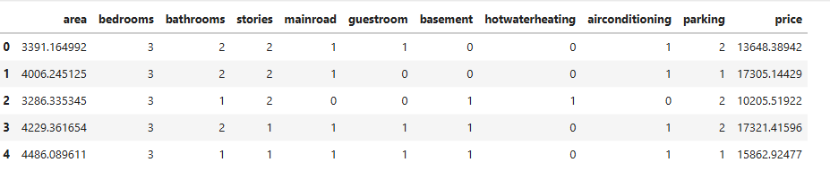
Question 2. Make prediction on the test set csv, and report the mean square error (MSE).
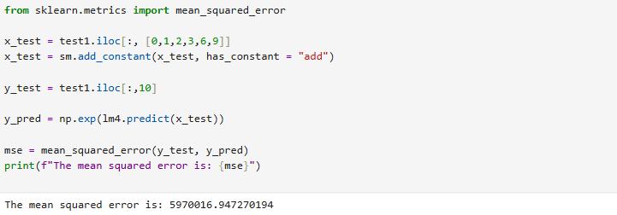
The mean squared error is 5970016.9473, which corresponds to and RMSE $2,444. This is a large deviation to the test housing price, indicating the model’s prediction deviate substantially from the actual values. However, the test set only contains 4 observations, this high MSE does not reflect fully the model’s overall predictive performance. Since all the assumptions were checked, the model demonstrates a proper modeling procedure in order to get the most accurate model.

